Technologist "Wanted Poster"

Category: Enrichment Activities
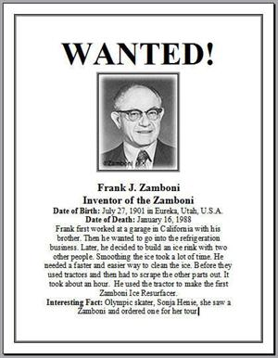

You will select a famous, or not so famous person associated with technology. He/She could be an inventor or a scientist. You are tasked with preparing a one page WANTED Poster for this person. It will outline and showcase the technologist's contribution to the world.

1. RESEARCH- You can use these 2 websites to find your information Also consider Google searches and using other web based dictionary or on-line encyclopedia for your research.

You must inform your instructor your technologist's names when planning to do this activity. Here are some helpful links to research this activity:
MIT's Inventor of the Week
What You Need To Know About Inventors

3. WANTED POSTER- Use Google Docs or a Word Processor Application to create your poster. It is all electronic, you will gain skills in "inserting a picture file" and "adding a page border".

